**L**

**A**

**I**

**p**

**r**

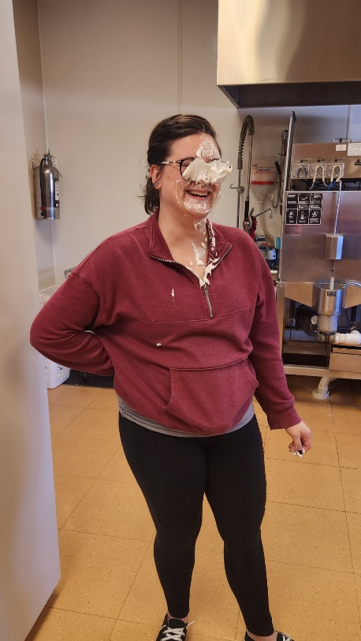

**Reminders:**

**Please be checking inside your child’s cubby and taking any artwork home. Please make sure to keep an extra pair of clothes in your child’s cubby that is weather appropriate, and fits.**

**REMINDER of our Policy**

**If you are giving your child PINK EYE drops, they need to stay home for 24 hours after you have started the drops.**

**If your child is sick, they are to be FEVER, DIARRHA, and PUKE free for 24 HOURS AFTER their last symptom.**

**.**

**No School April 12th E- learning day**

**For National pie day our grape friends chose to pie Mrs. Shayla in the face. It was a ton of fun and many laughs were shared.**

**HAPPY BIRTHDAY!!**

**Raelyn 27th**

**Bexton 30th**

**Everly 21st**

**Emerine 27th**

**Dawson 23rd**

**Madelyn 6th**

**Piper 2nd**

**Quin R. 25th**

**Ms. Tonya 20th**

**Ms. Sam 7th**

**Ms. Nikki 24th**

**Ms. Savannah 24th**

**Administrator:**

**Tonya Dillingham**

**Center Director:**

**Brittany Ortiz**

**Carealot Supervisor**

**Shayla Buchkowski**

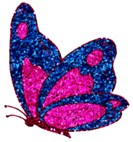

**Infant A: side 1**

**March flew by so quickly we can’t believe it is April! Please make sure you are checking your child’s cubby so there is appropriate attire for the weather. I recommend having a thicker sweater saved her as we go outside when the weather permits. We would also like to welcome our new friend Andie into the room. It’s always exciting to have a new friend in our room.**

**Last month, our unit was Dr. Suess, and your child was able to read,”1 Fish 2 Fish, Red Fish, Blue Fish.”**

**They enjoy doing art with their tiny feet and being able to watch our fishes swim in the indoor fish take. Many enjoyed dancing to fast songs and playing with musical instruments. These activities help your child with their sensory development as they get to explore different sounds, it also develops their touch and sight as they get to explore textures and the colors of the instruments.**

**We hope you have a wonderful month!**

**Ms. Kalia, Ms. Savannah**

**Infant A: side 2**

**Another month another newsletter here to keep you in the loop and up-to-date on all things Infant A-2. As per usual our room is busy and growing like crazy! We are hitting milestones every week. It's seriously one of the greatest gifts of this job; seeing your children grow and develop.**

**If you're like us, you're trying to figure out how Easter snuck up on us so quick! Bunnies, carrots and eggs oh my! We hope y'all have the best holiday!**

**April's theme is going to be a fun one-CIRCUS!! 🎠**

**We have one special birthday coming up Dawson will be ONE April 24!!!**

**Ms. Beth, Ms. Sam, Ms. Savannah, Ms. Toni**

**Cherry Room 1**

**In the cherry classroom, we learned many new things in March relating to Dr. Suess. We read a lot of books, learned colors through art, and even learned some new fun songs! We also practiced our ABC’s, shapes, and counting. Our learning will continue through April.**

**In April we will be learning through the theme of the circus. There are many fu activities planned, and we are super exited to teach our cherry students so many more things!**

**Also, don’t forget, on side one, we have started doing themed Fridays every week. Letters will be sent out before the first of the month to let you know what each week’s theme is. We hope your kiddos have lots of fun!**

**Thank you from your teachers,**

**Miss Abby and Miss Kristi**



Cherry Side 2

**Hello Families,**

**March was so much fun, we learned all about Dr. Suess! We made green eggs and ham and read all about Sam-I-am!**

**We got to enjoy all the seasons this month. We said goodbye to our friend Allen and welcome to our new friend Selene 😊**

**April showers will hopefully bring may flowers. We will be welcoming a new friend Reed to our side. This month’s themes are everything Circus. we already started making elephants on a ball for our window. We will be learning about clowns and maybe have a little face painting fun!**

**Ms. Diana**

Olive Room:

**March has flown by, and the month of April is already here! The olive room has been a busy and fun place the march as we explored al things Dr. Suess. Our friends especially enjoyed and listening to the cat and the hat. We also had lots of fun celebrating Easter, by doing lot of fun art projects, dying easer eggs, having an easter egg hunt and watching a Easter Movie!**

**During the month of we really enjoying our time spent outside as the weather allows, our friends have enjoyed exploring the melting snow, ice, and mud. As we look forward to nicer weather ahead, please continue to make sure your child has a jacket, hat, and mittens for those chilly spring mornings. During the Month of March, we gave a big welcome to Allen as he graduated from Cherry room to Olive room. During the month of April, we look forward to celebrating with Maddy and Miss. Nikki as they celebrate their Birthdays.**

**The Month of April, we look forward to the theme all about Circus, we will be exploring and learning about the things you would see at a Circus including animals, people, and Food. As Always feel free to come to us with any comments, Concerns or Questions you may have and thank you for your support as we continue to learn and grow everyday here in Olive room.**

**Ms. Becky and Ms. Nikki**

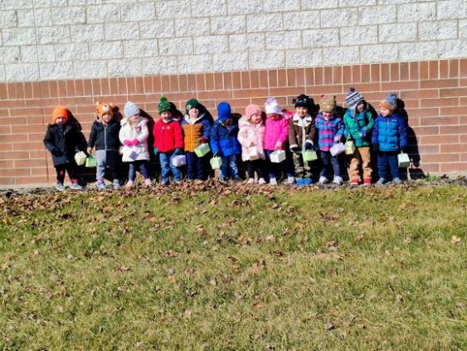

**Blueberry**

**Hello Blueberry families, the month of March was a productive one in our Blueberry room. A new teacher started in Blueberry the beginning of march so there will be a total of two teachers in Blueberry from here on out. Science has been a very prominent subject this month, with displaying chemical safety we make ordinary objects do fun things! Blueberry friends joined the grape friends for a volcano experiment with baking soda and vinegar, combining the two make a bubbly explosion! Germs are part of everyday life, especially with young children, so we did an experiment with water, black pepper, and dish soap. When applying dish soap to the black pepper and water it pushes the black pepper to the edge of the water showing that soap “scares” the germs. Since there are two teachers in Blueberry, we have been able to focus on team building activities and leadership values, such as working on a puzzle together while using our words to talk about what piece they need for that section.**

**ion of puzzle, our Blueberry friends have really shown amazing leadership skills such as making their own choices rather than following actions of other friends. You also may have noticed some physical changes to blueberry, we are in the process of switching out toys and rearranging our classroom, so it is more engaging to our friends, so please bear with the mess at times!**

**The month of April we have a circus theme to base our lesson plans around. While continuing leadership skills and communication improvement, but with some circus fun. Circus dramatic play items will be added to our room, in return we will be practicing for our very own pretend circus! Since science peaks the interest of our friends we will conduct science projects that reflect the circus, such as make slime that has the swirling colors of a circus, or even making elephant toothpaste! An exploding mixture of chemicals that when mixed it turns to foam and springs almost a foot into the air! We will mix colors of the circus to show what happens when combining certain colors together. For fine motor skill improvement, we plan to fill our sensory table with packing peanuts and small containers to pack them into. Circle time in the mornings will be extra fun when we dance like were in a circus act after talking about animals and food from the circus! Mr. Mike and Ms. Mackenzie**

